Draw the Path — Portfolio Sitemap + Toolkit
Ahmed Elgharably — FlyRank AI Fluency, Week 1 deliverable

1. Portfolio sitemap
Built from Ahmed's existing portfolio deck (Home/hero, About, Education, Skills, Experience, Services, 2 Projects, Contact), condensed to four pages so every page earns its place against the claim and the one action.
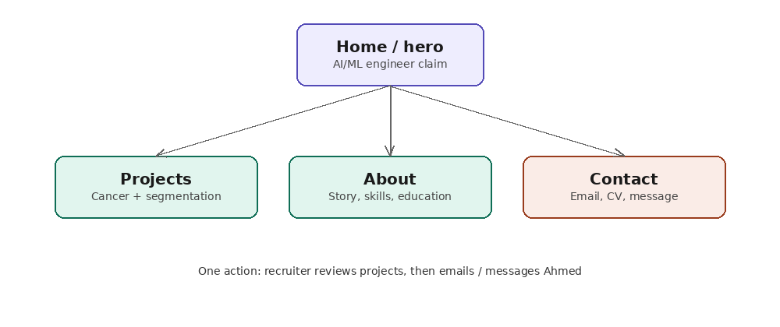
Note: the deck's "Services" section (ML / DL / CV / Data analytics) is not a separate page — it's folded into the Home hero as a one-line skills summary, and into the Projects page as context for each project. This avoids repeating the same claim three times.

2. Proof statement
Paste this into the Claude Project's custom instructions, and use it as the one-sentence test for every page and headline you write.
"I'm Ahmed Elgharably, an AI/ML engineer (Faculty of Computers & Information, Damietta University, 2022–2026). I build predictive models, classification systems, and computer vision pipelines from real datasets — with hands-on training from NTI, ITI, and independent CV/ML work. My portfolio proves I can take a project from raw data to a working, evaluated model, not just theory. Target: recruiters and companies hiring for ML/AI internships or junior roles. One action: they view my two flagship projects (Breast Cancer Prediction, Customer Segmentation & Classification) and email or message me."

3. Claude Project — custom instructions
Project name suggestion: "Portfolio Build — Ahmed"
Custom instructions to paste:
"Act as my portfolio tutor for this 8-week build. My proof statement: [paste the proof statement above]. My one action: a recruiter reviews my projects, then emails or messages me. Judge every page, headline, and project description against whether it moves a recruiter toward that action. Flag generic buzzwords ('innovative', 'lasting impact') that don't prove anything, and flag unfinished template artifacts (placeholder links, addresses, typos) before I publish. Keep feedback specific and short, not generic encouragement."

4. Pressure-test — prompt and output
Prompt:
"Pressure-test my sitemap (Home, Projects, About, Contact) against my one action and my claim, using my actual deck content."
Output:
- Home ⚠ — the claim is generic ("innovative and precise solutions... lasting impact"). Needs something concrete: e.g. "CNN-based diagnostic models" or "end-to-end ML pipelines from data to deployment."
- Projects ✓ — the strongest page, but descriptions are all process/tech-stack with no result numbers (accuracy, F1, dataset size). This is the single biggest gap for convincing a recruiter.
- About ⚠ — visible typos to fix before publishing: "impac" (impact), "Portfolio serviceo", "soft techinal", and "MEC 2024" is unclear.
- Contact 🚩 — unfinished template placeholders still present: "www.reallygreatsite.com" and "123 Anywhere ST., Any City". These must be replaced before sending this to anyone — they signal the deck wasn't fully customized.
One thing to change: add at least one concrete result number to each project, and remove every template placeholder from Contact.

5. Portfolio corrections checklist
- Replace www.reallygreatsite.com with a real link (GitHub, LinkedIn, or live portfolio URL)
- Replace "123 Anywhere ST., Any City, ST 12345" with real contact details or remove the line entirely
- Fix typos: "impac" → "impact", "Portfolio serviceo" → "Portfolio services", "soft techinal" → "Technical skills"
- Clarify "MEC 2024" (what does this refer to?)
- Add one metric per project: dataset size, accuracy/F1 score, or a concrete outcome
- Rewrite the hero line to name a specific capability instead of generic adjectives

